**Experiment No : 1(a)**

**Name : Mohammad Sohail Shaikh A56**

**Code: Write a Python program to compute the future value of a specified principal amount, rate of interest and a number of years.**

**Code:**

def compute_future_value(principal, rate, years):

"""

Computes the future value of an investment.

:param principal: Initial amount of money invested (float)

:param rate: Annual interest rate (as a percentage, e.g., 5 for 5%)

:param years: Number of years the money is invested (int)

:return: Future value of the investment (float)

"""

# Convert rate to decimal

rate = rate / 100

# Compute future value

future_value = principal * (1 + rate) ** years

return round(future_value, 2) # Round off to 2 decimal places

# Example usage

principal_amount = float(input("Enter the principal amount: "))

annual_rate = float(input("Enter the annual interest rate (in %): "))

years = int(input("Enter the number of years: "))

future_value = compute_future_value(principal_amount, annual_rate, years)

print(f"Future Value: {future_value}")

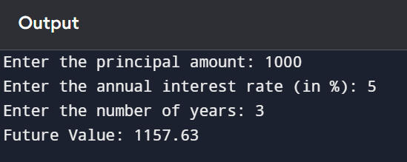

**1(b)**

**Code: write a python program to get the volume of a sphere with radius.**

import math

def sphere_volume(radius):

"""

Computes the volume of a sphere.

:param radius: Radius of the sphere (float)

:return: Volume of the sphere (float)

"""

volume = (4/3) * math.pi * (radius ** 3)

return round(volume, 2) # Round off to 2 decimal places

# Example usage

radius = float(input("Enter the radius of the sphere: "))

volume = sphere_volume(radius)

print(f"Volume of the sphere: {volume} cubic units")

